PROJECT NAME:

INSIGHT STREAM NAVIGATE THE NEWS LANDSCAPE.

TEAM DETAILS:

Team ID : NM2025TMID36377

Team Size : 4

Team Leader : KAYALVIZHI E

Team member : MALAR V

Team member : ANISABEGAM A

Team member : AMMU S

PROCEDURE:

-> Download Node.js LTS version

-> Select your system configuration and click on (Windows installer(. msi )) if windows

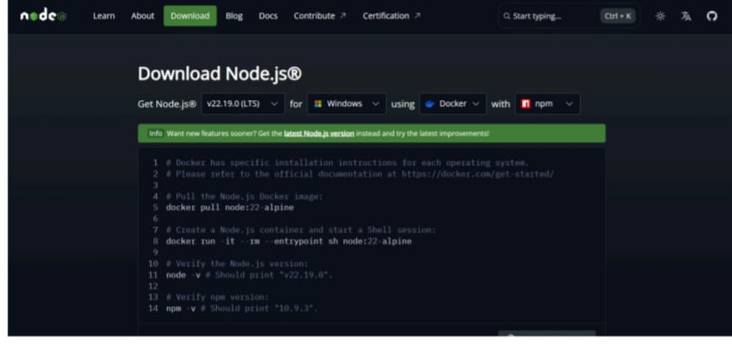

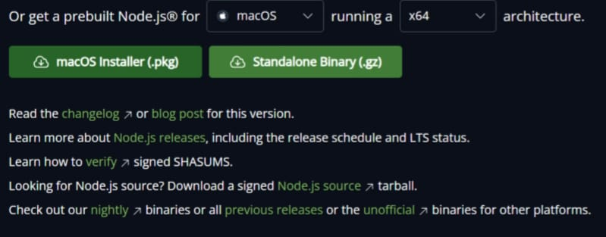

a-> After downloading, install Node.js by opening the downloaded file

and follow the instructions below.

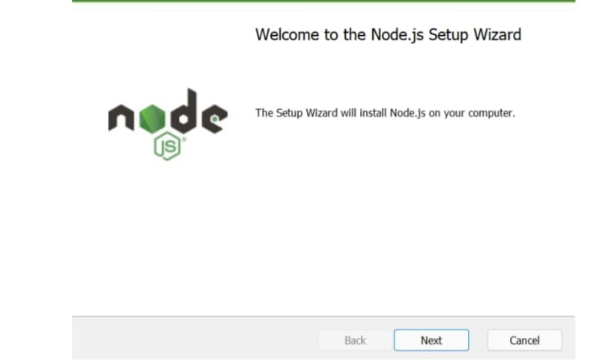

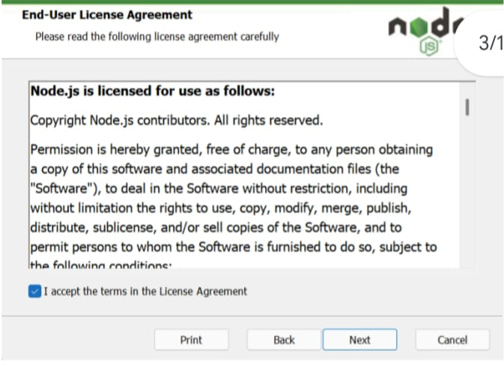

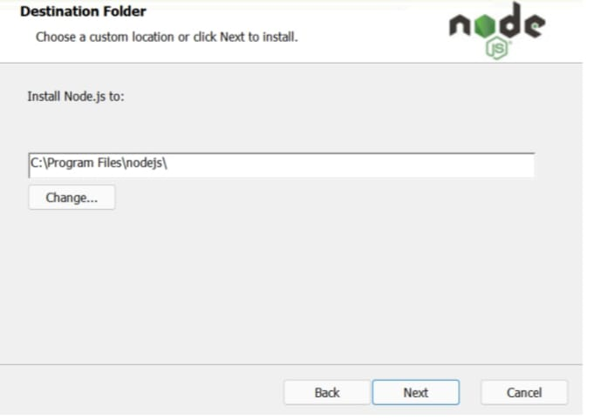

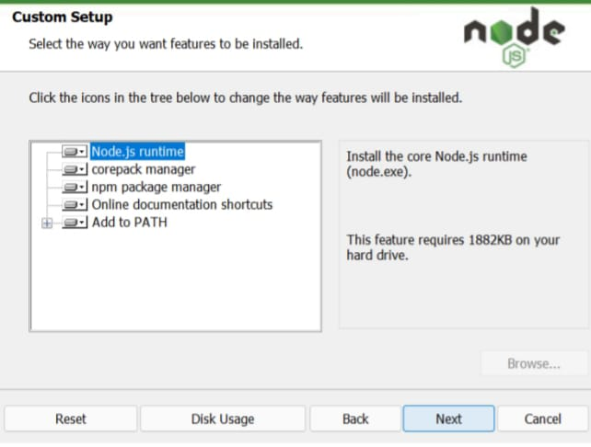

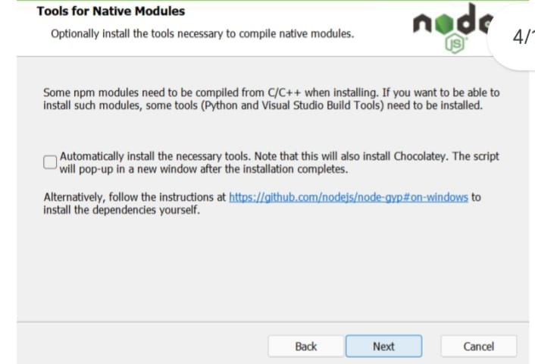

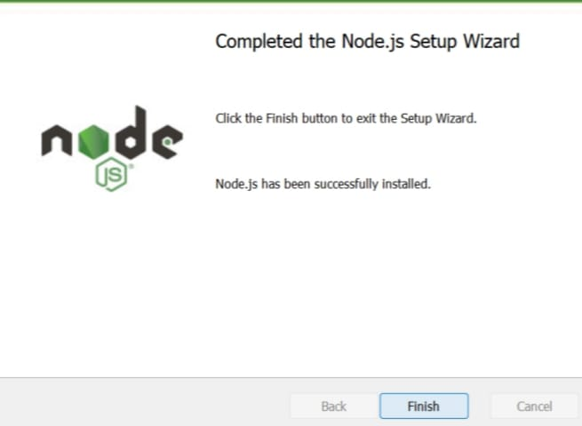

->After installing Node.js, open Windows PowerShell As Administrator

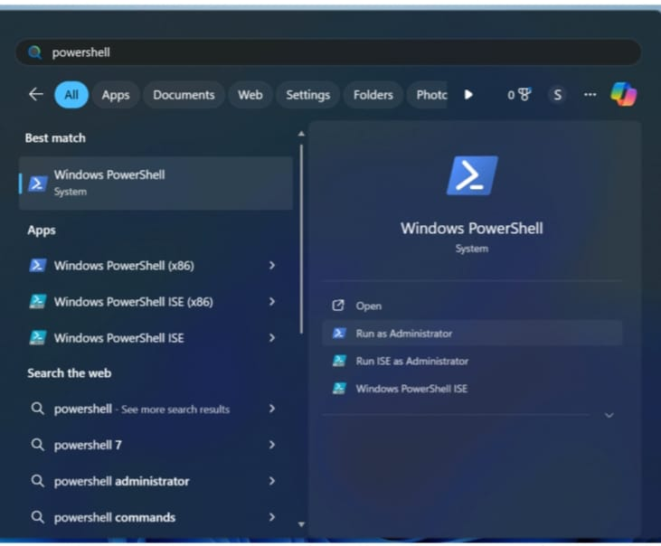

-> Type set- execution Policy unrestricted and press enter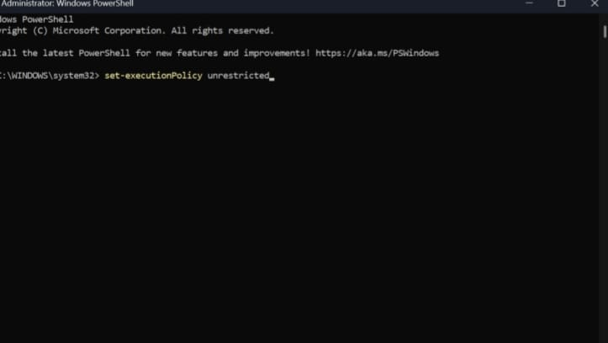

->In the next step type Y and press enter

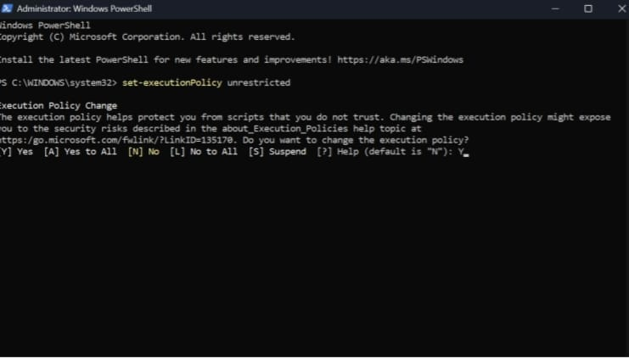

Steps To Download And Execute Project:

-> From your Smart Internz portal Go To Projects → Access Resources → Guided Projects → Go To Workspace

->Inside Guided Project you can find Project Flow

->Now you can see two links one is the demo video and the other is the code drive link.

->Click on the code drive link or copy paste that link in your new chrome tab.

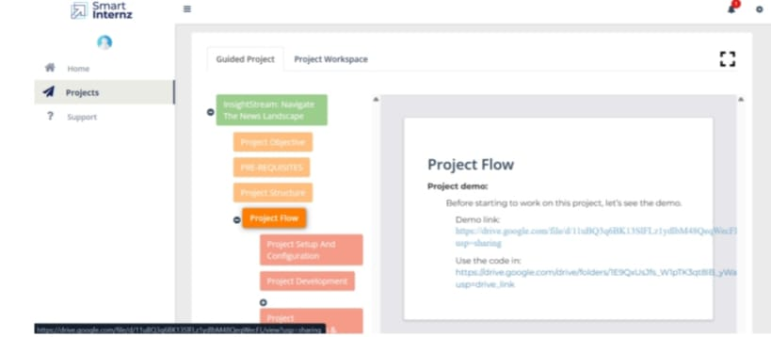

->Download the code folder

->Now go to downloads and right click on the downloaded zip folder and click on extract all ->Now click on Extract

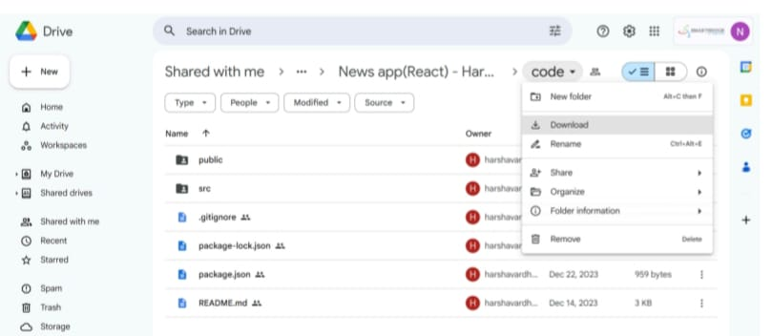

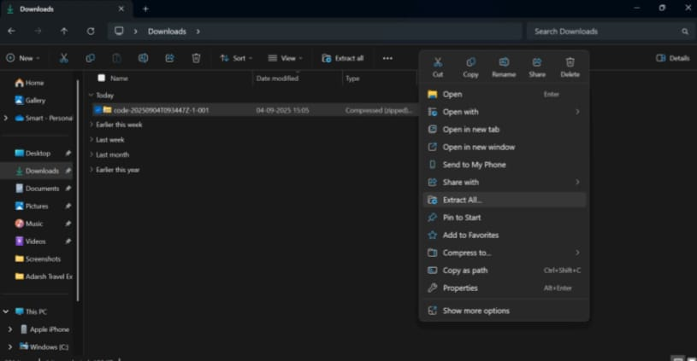

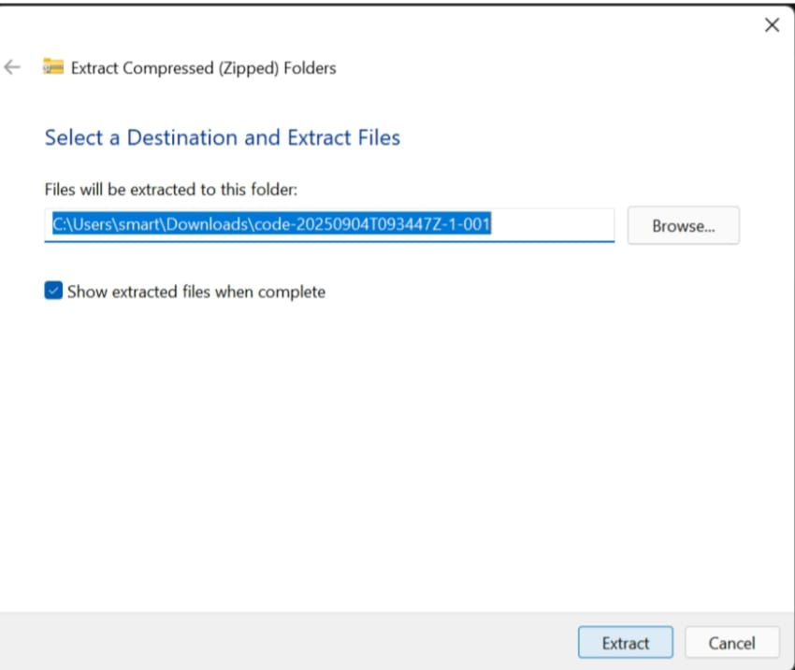

->Now open VS code and open the code folder from the extracted folder.

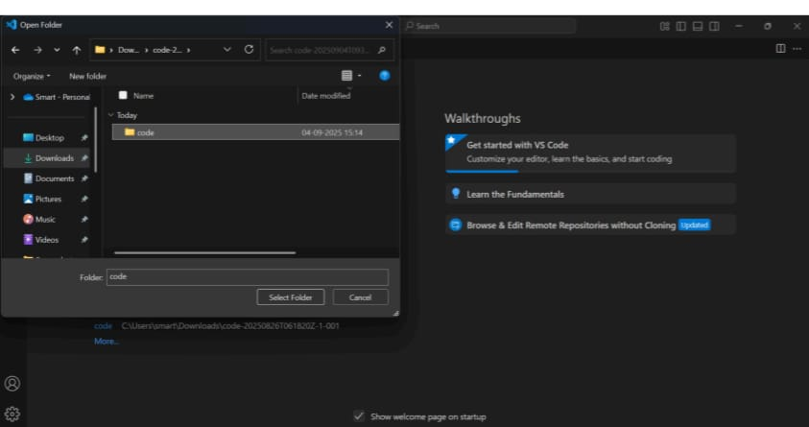

->Now open a new terminal.

-> Type npm install in your terminal and press Enter and wait till all the dependencies gets download

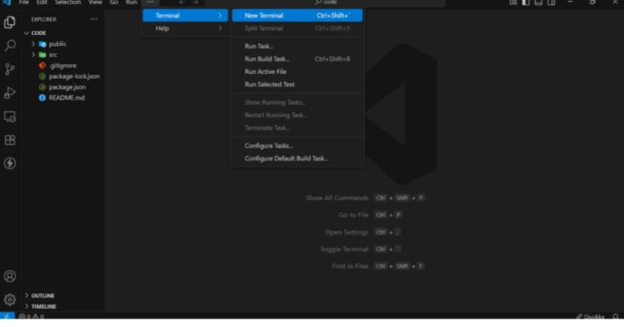

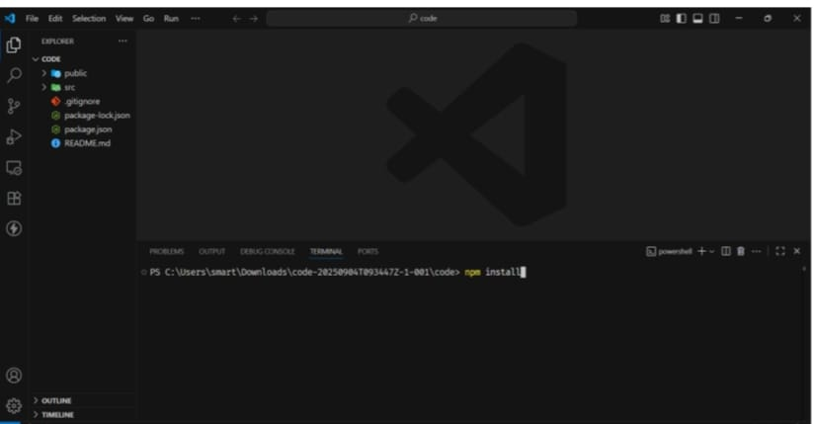

->After all the downloads finishes, now type npm start and press Enter

->Now your application will be opened in your browser with url http://localhost:3000

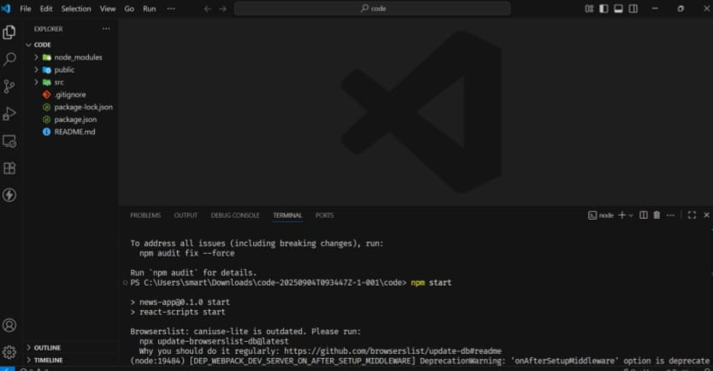

->Output screen and successfully complied message displayed in VS code

